NMD324: Elliot Chandler (Wallace) — Birdman favorite frame

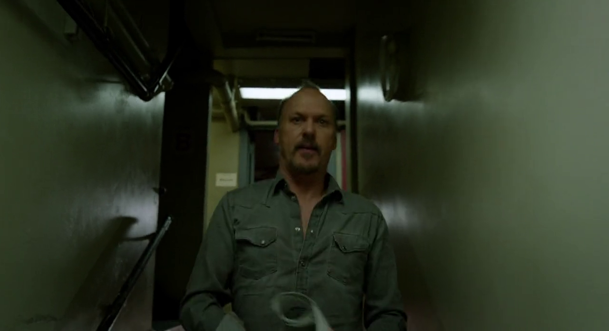

My favorite frame in Birdman is the one pictured above (55m29s), which is one of the shots used to transition between scenes. I find it very effective because it creates an evocative and intense environment. This has been a hard assignment for me to write. While choosing my favorite frame was very easy — I knew right away, instinctively, what my favorite was — figuring out how to describe what appeals to me about it is more difficult. Even now, I do not feel like I fully understand what draws me to this frame so strongly. The obvious element that attracts me to it is the use of pipes — I have a great fondness for the appearance of plumbing and wiring in buildings. What it is about those elements that appeals to me is harder to understand, though. I have had a great appreciation for that aesthetic for as long as I can remember, since I was very young, and it has certainly not faded with time. There are some other frames around this one with similar contents, but this seems like the clearest and most appealing single frame. There are also some other similar transition scenes that use pipes, but this was the most interesting of them to me. While the railing in this shot is not a plumbing pipe per se, it adds to the visual interest of that thematic element within the shot. A secondary aspect of the shot that I like is how the greenish appearance of the scene matches with Riggan’s shirt. I find that quite effective in tying together the frame visually as a cohesive whole.

